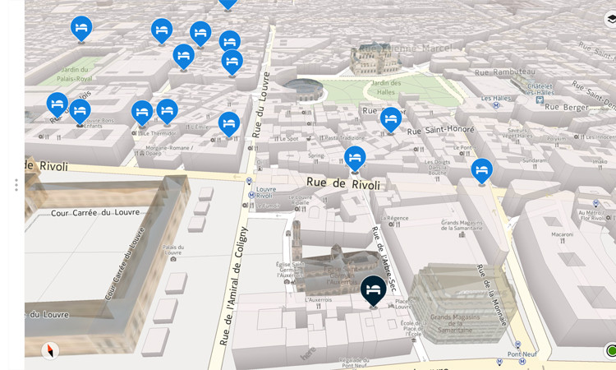

A mapping and database system to show all of the information you need in ways which make the most sense.

Location

Staff

Data

Links

Documentation

And More…

High School Intern Joint Mapping, Asset, and Information Proposal

# C:\Users\MHF823\Desktop\Untitled.pngSummary of the project

Your role:

This year you will be working on the first steps towards a Port-wide project for interns which will span the next five years. The goal of the project is to provide in a single database mapping information, asset information, financial coding, leases, contracts, knowledge / resource information, and contact information so as to be usable by other Port employees.

This year you will be working on a pilot program, discovering what information exists where, recording the contact information and connections you make for future reference, working with mapping specialists, reviewing system and program capabilities, and interviewing staff. At the end of your internship we expect an inclusive joint (or individual) report setting up the next year’s program.

You will need to do a significant number of interviews and collaborative work. While doing this work you can assure people that the work you are doing is a project in collaboration with the Maritime Finance, Legal, and Human Resources Departments. This project has been approved by Legal. If you have trouble with people please contact Meridith Fishkin, David Kleiber, or Amberine Wilson. These people can help you if you run into any trouble or feel uncomfortable in any part of your work or day.

The Environmental Finance team will be proposing a joint (multi-department) project for 2018 high school interns. Your project is to complete a test run of this proposal and write up a complete summary, proposal for 2018 interns, how-tos for each task, contacts and agreements with departments on work for 2018. This project, if successful in 2017, could expand to a Port-wide annual exercise for a team of 30-50 high school interns in 2018.

Currently the Port keeps information in several systems separating vital data which could increase staff efficiency by magnitudes. We propose to create a comprehensive database adding additional information on the marine maintenance mapping system which would include the following:

# High Level Breakdown of the Knowledge Table & Map System

**Knowledge Table**

In an online database

* Staff contact information (Phone # - phone book) (ALL info Outlook)
* Staff name (phone book)
* Job Title (Outlook)
* Staff Home Org (Outlook)
* High Level Position Responsibilities (Possibly with HR)
* By staff member knowledge and responsibilities (Knowledge Table) (Not located anywhere)

**On maps and in the above database**

Contact information & Staff Responsibilities

By location

By project manager

Maintenance staff

Billing staff

Emergency Contacts

Lease Holders with contact information

Financial / coding information

Subclass

Org

Program

Asset ID

Lease numbers

Utilities

Stormwater utility / non-utility breakdown

Other utility and electrical breakdown

Other

Links to SharePoint sites by groups for relevant information

Links to As Built Docs in Eng Database

Property Name

Property Address

Building Names

Building ID

Litigation Hold Information

Location information

               Parking Information

Travel Routes

Gate Information

Conference Room Location

Lease Holders

I would like to make this accessible to ALL Port employees online. In order to make this accessible to all Port staff you will have to work with Elisabeth Black and the legal team to make sure you are not adding confidential information.

Unlike the map books it will provide information and data to an updatable system. An electronic database will provide a cheaper alternative to a paper booklet, provider an easier way to update data, and have the potential to provide a greater range of information about the properties and reducing both the Port’s carbon footprint and financial burden.

# Port Staff Resources

**Lead:**

Meridith Fishkin

**Partnerships:**

Lilly Ninburg – Google Maps

Teresa Sante & Nani Narag – Marine Maintenance GIS Mapping System & Harmony App

Randy Edwards – Environmental GIS Mapping

Project Managers (Multiple Departments) – Active Projects / Last Project Completed

Marine Maintenance – Maintenance Projects / Site Visits

Mike DeSota & Others - Utility managers

Maritime Finance – Assets

Gary Ensley & Adam Dreller – Engineering Asset Information and As-Builts

Bird Gillespie - Facilities Asset Information

Kelli Goodwin – Piers at P69 and T91 management

Environmental Finance & Corporate Finance – Financial coding information & Project Lists

Real Estate – Lease Documents (Links)

Maritime Environmental – Links (Property SharePoint Sites)

Engineering – Links (Property SharePoint Sites)

Construction Management – Links (Property SharePoint Sites)

On site staff – Knowledge Tree / Assets / Property Information / Location information

ICT – Staff Information

Elisabeth Black – Litigation & oversight of released data

Vanessa Ressler – Retention Schedules

As you can see, not all of the information has been filled in. You will need to make your contacts at the Port. As you go forward you will need to contact people who can help you put together your test project and then prepare the program for 2018.

# Knowledge Table Part I

The image below is not intended for use, but only as a starter. Be creative with your database.

A knowledge table is like an org chart, but instead of organizing people in a company you are organizing knowledge. You should begin by looking at the Port’s Org for the [Maritime Division](http://compass.portseattle.org/seaport/Pages/MaritimeOrgChart.aspx).

The Port Org chart tells you the name of the person and their title. You can click to view more about most people. But the information you get isn’t very in-depth.

Think about what information you would want to include if you were trying to make a helpful tool for people to ask questions. For example if you needed help getting an invoice paid which of these people would you ask for help? What if you needed help finding out about an [asset](https://www.fundingoptions.com/knowledge/asset/) at a Port owned Park?

Write up an email with what you think the important information is and send it to Meridith Fishkin. Feel free to include your rational, but it isn’t required in the email and some information doesn’t need to be justified.

Now think about how you want to present the information. Go look at org charts, knowledge charts, knowledge matrix, customer paths, and other kinds of data presentation. You can even ask the Business Intelligence group for suggestions. Read their piece here:

**What’s all the buzz about Business Intelligence?**

Do you ever stare at a spreadsheet of data trying to glean some insight from it? Spend hours working and reworking graphs and charts?

***You’re not alone!***

But now you have help in-house. The Business Intelligence department (BI) is your resource for understanding and presenting data, so that you can spend time making better business decisions from it.

Visit [BI-Hub](https://bi-hub.portseattle.org/) or [email us](mailto:BITeam@portseattle.org) to learn more about BI’s offerings, such as Data Doctor, our online learning resources and more. Get in touch today; you’re just a minute away from support!

They can help you with design ideas. While you’re there you can also ask them what they think of your project and if they have any ideas.

You should also look at a property level view of an organization chart at the Port. Look for the Master Plan index from Marine Maintenance please ask Teresa Santé to borrow a copy. You might also want to meet with her and discuss how she put these records together, how to access them, and if she has any other ideas for your project.

<http://compass.portseattle.org/seaport/Pages/Marine-Properties.aspx>

Once you have some ideas make an appointment with Meridith Fishkin you will be presenting / discussing what you have discovered.

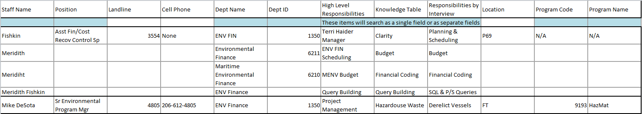Items in Blue are independently searchable

# Knowledge Table Part II

Now that you have a plan it’s time to put together a list of questions. Complete a list of questions you would like to ask people, fill in all of the pieces you can find using the resources below or any others you’ve discovered on your way.

Write up an email introducing your selves, explaining the project, your request to interview people, and your questions. Review each other’s work and decide what to include. Send the email to Meridith Fishkin for review.

Setup a time to interview these people, you will send them the email above as a way to introduce your selves and set-up meetings with participants. If they do not wish to participate this year that is OK, keep records of who you interviewed, they’re answers and those you did not interview.

Start with …

Fishkin, Meridith <Fishkin.M@portseattle.org>,

Kleiber, David <Kleiber.D@portseattle.org>,

Haider, Terri <Haider.T@portseattle.org>, and

Wilson, Amberine [Wilson.A2@portseattle.org](mailto:Wilson.A2@portseattle.org),

… you should interview these people together, ask for advice and feedback.

Now you’re ready to divide and conquer. Separate the listing and start contacting people.

**Confirmed Staff**

**AFR Business Technology Group**

Rachel Petrich

Sharon Munday

Diane Armstrong

Laura Hall

**Environmental Finance**

Dave Kleiber

Kiu Holmes

Meridith Fishkin

Terri Haider

**Corporate Finance**

Kelly Zupan

Debbie Calhoun

Tyler Cooley

Yuling Zhou

**Other Departments**

LaCretiah Claytor

Vy Donnelly

Bird Gillespie

**Marine Environmental:**

Kathy Bahnick

George Blomberg

Persia Brown

Terrance Darby

Mike DeSota

Jane Dewell

Randy Edwards

Joanna Florer

Joseph Gellings

Nicola Graham (NWSA)

Stephanie Jones Stebbins

Roy Kuroiwa

Matthew Mateo

Paul Meyer

Srinivas Pendikatla

Jon Sloan

Brick Spangler

Brenda Thomas

Using the Port’s Org chart add the information to the knowledge table; include email, phone numbers, staff titles, division, team, and organize the chart with co-workers and supervisors. Limit this work to people you worked with on the Knowledge Table.

If you need help utilizing systems contact Terri Haider (Access) or Meridith Fishkin (Excel, Outlook).

Outlook Directory

Available by double clicking on a name

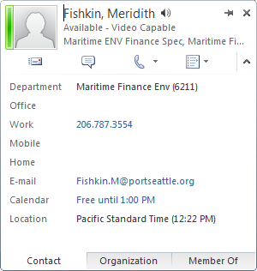

Phone Book

<http://phonebook.portseattle.org/>

Now that you’re done you need to review your answers for accuracy and completion. Follow-up with anyone you have questions about. Enter your findings your database. Send it to your piers for review and then to Meridith Fishkin and Dave Kleiber for input.

Once you receive feedback it’s time to make changes and think about formatting. How would like your knowledge table to look?

# Litigation Hold & Retention Schedules

We would like you to learn about retention records and litigation holds so that you can create a SharePoint site / library where

* The legal team can post active litigation holds,
* Staff can read about active litigation holds, records retention policies, find out how to store documents, emails, media, and notes as required.
* Staff who need can find all of the related files to litigation holds

And so that you have a basic understanding of what kinds of information can be shared throughout the Port and how information can be shared or classified as confidential.

Much of what you will be asked for in this project is already done and after reviewing the documents you can simply add links, as long as everything is the same place efficiency for this kind of work is greatly increased. Some of these links are protected; you will need to find a way to keep them confidential or to tell people who to ask should they need to reference the documents.

Part 1 Discovery

Interview Meridith Fishkin for a brief overview of litigation holds and what they might affect what you are working on for your work. Ask Meridith about confidential SharePoint sites.

Interview Vanessa Ressler about the kinds of litigation holds and what they might affect

Interview Elisabeth Black about the legal issues with litigation holds and how that affects storage of records, law, and the Port’s practices.

Talk to IT (Amberine Wilson’s Position) about email backup and who /why there are different deletion dates on emails.

Talk to Mike DeSota about the Maritime Environmental SharePoint Sites for projects. Ask him to give you a brief tour of the SharePoint Site(s). Ask for links.

Have a meeting with Meridith Fishkin about what you think the Port should be telling people internally and externally about litigation holds.

Keep these questions in mind as you work through your interviews and meetings.

* What do people need to know?
* Where do they store their files?
* How do they make sure they are compliant?
* What do they need to do if they receive a FOA request?
* Who else should you be talking to?

Take this information and share it with your colleges who are working on other aspects of this project. They will need to know about litigation hold and confidential information as part of the knowledge table and mapping work pieces.

When you’re ready ask Meridith Fishkin or Dave Kleiber to see the Standard Operating Practice (SOP) site. Read through a few of the SOPs. Write one yourself for anything you do (be ready to share it). Ask another intern to help you try it out. When you are ready email it to Meridith Fishkin and set up a meeting to discuss your training SOP.

Bring a list of other trainings or information pieces you think people should know about to a meeting with Meridith Fishkin.

Work on your training pieces, give them to other interns and ask them to review the pieces for you. Ask for honest feedback not just about ease of reading (spelling, grammar, sentence structure, and layout) but also for content and knowledge. Remember to encourage bad feedback; you aren’t an expert yet, you’ll need to internalize and process criticism to become the expert for anything you do and it can’t happen if people lie to you.

While you work on this task remember to send daily emails with a daily report to Meridith Fishkin.

When you’re ready to present your discovery and your SOP email your SOP to Meridith Fishkin. Then setup an appointment for an hour on her calendar. Think about how you would like your SharePoint site to look.

Part 2 Implementation

Implement your ideas. You’ll need access to SharePoint to create a new site / library for your retention records page. Make sure you don’t delete anything and that you save the html link to any new sites you create (the links don’t always show up on the navigation panel).

If you need help you can get assistance from:

Meridith Fishkin

Mike DeSota

Terri Haider

Online help

Microsoft help center

And our ICT department (x3333)

# Mapping Preview: Internal Mapping

The Port has several internal mapping systems:

Lilly Ninburg – Google Maps

Nani Narag – Mapping System

Randy Edwards – Environmental GIS Mapping

Gary Ensley – CAD Engineering Mapping System

Brian Taylor – Internal Mapping AOB

Scott Silcox – GIS Mapping

Some of these mapping systems can be reached by the public, like google maps and the public Port maps on our websites for the airport and the cruise terminals. Some of our maps are internal only and hold more detailed internal information; internal maps can even be confidential.

Make an appointment (if you haven’t already) to interview each of the people listed above for a tutorial on the mapping systems. The Port’s internal mapping systems are called [GIS](https://en.wikipedia.org/wiki/Geographic_information_system) based mapping software. GIS maps can be harnessed to do extraordinary things. [ESRI](http://www.esri.com/what-is-gis) has a great page on GIS mapping as does Wikipedia. You can do some browsing to find other uses and ways to use GIS mapping software. Be ready to ask specific questions including information collection and input, how to distinguish layers, data, links, contact information and more to maps.

For this project you will be adding information to the GIS maps for Pier 69. Start by asking the GIS maps staff for everything they have on Pier 69. Now think about what you can add, what would be helpful?

Maintenance Contact Information

Emergency Information

Asset ID numbers

Life of Assets

Location of Assets

Financial Coding

Subclass

Lease Holder information

Tariff & Tax

Active Litigation Hold

Stormwater Utility Vs. Non-Utility Mapping

Links to active leases with the Real Estate Department

Links to active contracts

Related Business Units

Alternative Name(s)

Property Address

What else would you add?

Joseph Pelonio – Leases

Will meet with you during your first week at P69; he is a Portfolio Manager for the Port dealing with leases and assets. He wants to work with you on accurate mapping, substations, lift stations, and meter billings among other things. Even though you’ll speak to Joseph during your first week, keep him in mind as you go throughout your project as a resource and someone to work with.

These people work with mapping systems and assets. Contact them about your project, show them what ideas you have, ask them for more.

Debbie Calhoun - Assets

Fred Chou – Project Manager

Sam Asavreungchai – Engineering

Srinivas Pendikatla – Stormwater

Vy Donnelly – Engineering Finance

LaCretiah Claytor – Maritime Maintenance Finance

Bird Gillespie – P69 Facility Management

Roy Kuroiwa – Environmental Project Manager

Kelli Goodwin – T91 Manager

Kelly Zupan – Maritime Finance Manager

Elisabeth Black – Legal (What information is confidential?)

Look at your knowledge table and through the Port’s Organizational chart. Who else should you be asking? Contacts some people not listed, the best way to do this is through email, and ask them for input.

When you are done with your mapping interviews, edits, additions and proposals create a working set of documents from your interviews, observations, and previously completed documents to hand in. These documents should reference your ideas, your conclusions, what you did and didn’t decide should be in next year’s project, who you contacted, what they helped you with and if you think they would like to participate in future work.

# Images

**Harmony Images**

On the iPad Mini you will find an app called Harmony. You will receive a tutorial from the Marine Maintenance Department on this app. Harmony allows you to take photos and integrate them onto the GIS mapping system.

**Public Photos**

We will be asking you to take “panoramic” photos for public outreach. Speak with Teresa Sante and Lilly Ninburg about what kinds of photos they are looking for. Additional outreach should be done with any site managers you speak to about site visits for this year or next year and with Public Affairs regarding any additional photos they might have need or would like copies of.

Before taking photos for the public please remember what Elisabeth Black has to say about internal vs. external exposure.

**360deg Photographing**

The Engineering Department at the West Field Office will be showing you how to use a rather nifty piece of equipment. This camera takes 360deg photos without multiple takes or digital editing. Next year this team would like us to take photos of the airport and several other facilities.

# GIS Mapping Proposal

Work together to create a plan like the one below; what information would you keep? What information would you add? When you are done consult the experts, what can you really do in the system? Consult legal, ask them what you are allowed to do. Follow up with Meridith Fishkin.

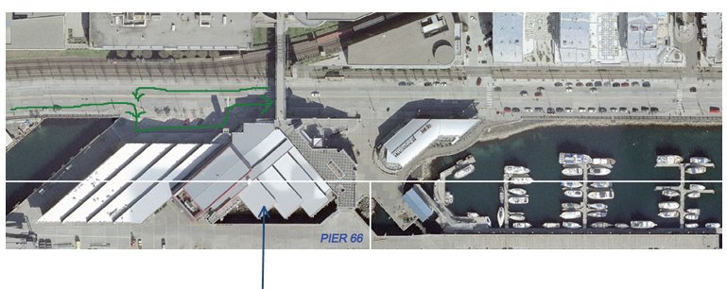

Property Pier 66 Conference Building

Building Manager: Tim Brayner (Imbedded link to email) 206-787-xxxx

Maintenance Contact: Sam Raynold (Imbedded link to email) 206-787-xxxx

Booking Manager: Rina Altross 206-787-xxxx

On-Site Contact During Rentals: Wes Orin 206-787-xxxx

Emergency Contact : Fire or Flooding: 911

Grace Rafferty 206-787-xxxx

Police Contact: 911

Grave Rafferty 206-787-xxxx

Not Leased

Stormwater Utility Code 9874

Electrical Monitoring Station 468574

No Current Litigation Hold

Municipal Waste SPU Tuesdays 6695478S1

Parking available at World Trade Center Garage

Short Term parking available in front of the building

Org 5256

Subclass 5210

Asset ID 64110

Program 5544

Links:

Project Management Group: New Overhang (Imbedded Link)

Marine Maintenance: Room 7 repairs (Imbedded Link)

Marine Maintenance: Roof Assessment (Imbedded Link)

Maritime Finance: Asset Information and financials (Imbedded Link)

Port Budget (Highlighted segments for the site) (Future Work) (Imbedded Link)

Travel Route C:\Users\MHF823\AppData\Local\Temp\msohtmlclip1\02\clip_image004.png

No Gate

# Mapping Preview: Google Mapping

Machine generated alternative text: This is an online Google T91 Map with
customized layers of info/data that can
be viewed via Internet (phone or
139 views
SHARE
Tenant (Lease#)
All items
Building/Area Names & Markers
All items
Entry Gates & Traffic Routes
4..’ Cj East Gate
Main Gate (Magnolia Bridge Entry; Unde...
4 Main Route
Main Route2
... 5 more
SeaOps Incidental & Incremental Use...
Short-Fill Parking (Cruise, Fishing, Events)
SeaOps Marshalling Yard

This map by Lilly Ninburg is for Public use. It shows locations of building, building names, and other public information we don't wish to make available only by FOIA requests such as internal financial coding.

Any information built into this map is considered public knowledge.

Work together to create a google map like the one above; what information would you keep? What information would you add? When you are done build your map. Make sure to consult Elizabeth Black in legal or consult with one of your colleges who worked on the Litigation Hold & Retention Schedule piece to ensure no confidential information is being disclosed. Follow up with Meridith Fishkin.

# Asset Update

**Projects with Meridith Fishkin & Dave Kleiber**

Maximo Assets

Now that you’ve worked with theory it’s time to try it out. Take your P69 maps, the Maximo Asset list and find every Pier 69 Asset on and off the books. Look for leases, projects, art, elevators, Tables, Benches, Chairs, and anything else that might be considered an asset. Make sure the assets are where they should be, that the Asset description matches the tag, the Asset is even in the log, and any other discrepancies you can think of.

Think about what you would need to do to identify Assets on a map of Pier 69. Would you even want to? Revise your document set and include a how to for the students who come after you. Remember they may be working at remote sites and will not have your experience.

Build out a GIS map with Assets which cannot or are not likely to move at the Port. You can use previously build maps if you can find them.

**Projects with Bird Gillespie**

Door Asset Tags

Inventory of the Small Moveable Assets in the 3rd Floor Closet

# Properties for 2017

P69

# Additional Misc / Research Work

Asset Tags for Chairs & Desks

Currently the Marine & AV Maintenance Crews paint asset information near outdoor assets like man-hole covers or utility boxes. This is not a permanent solution. Find out on average how long these “tags” last. Do some research on other options and make a recommendation based on permanency of tag and cost to implement how we should continue to mark these assets.

Set-up a SharePoint site for the 2018 [SYL Internship Project](http://collab.portseattle.org/sites/SEP_Finance/ENVFINCONTROLS/Meridith%20Fishkin/2018/Internship%202018/Internship%20SYL%20Proposal.docx).

Reach out to these additional people; see if they can help you develop this project for future years or if they have other ideas to incorporate.

Deb Sorenson

Pothier, Kelsi

Eric Shaffer

Greg Whiting – Electric Metering

# Appointments

Tour of Shilshole Bay Marina (SBM) & Lunch with Mike DeSota Friday the 14th 9:30 – 12:30pm

Tour of Terminal 91 (T91) with Ed Friday the 28th 1-4pm

Retention Records Introduction with Vanessa Ressler July 11th 9-10:30

Environmental Finance Bi-Weekly Team Meetings July 11th 10:30-11

# Future Work

If this project is successful there will be an opportunity to facilitate a Port wide Project in 2018 - 2021.

# Potential Future Sites:

Please fill-in ALL Port sites you can find both Maritime and Airport, Parks, Off-site locations, or Port Owned Properties or Buildings.

* + P66 & World Trade Center
  + Jack Block Park
  + Centennial Park
  + Terminal 107 Park
  + Smith Cove Park
  + Jack Perry Memorial Park
  + Terminal 105 Park
  + Terminal 18 Park
  + Terminal 102 Park
  + 8th Ave S Park
  + Sea-Tac Airport (Auxiliary Buildings)
  + Terminal 91 Bike Path
  + Pier 86 Elliott Bay Fishing (This is not be our asset, but it is a part of centennial bay and on our website as a public access point.)
  + Bell Harbor Marina Corporate Center at Terminal 102
  + Terminal 5
  + Terminal 18
  + Terminal 25 / Pier 27
  + Terminal 28
  + Terminal 30 / Pier 34
  + Terminal 46
  + Terminal 86
  + Terminal 91
  + Terminal 102
  + Terminal 103
  + Terminal 104
  + Terminal 106
  + Terminal 107
  + Terminal 108
  + Terminal 115
  + Terminal 117
  + Pier 2
  + Tsubota
  + Marine Maintenance Building
  + Fisherman's Terminal
  + Harbor Island Marina (This site has litigation)
  + Shilshole Bay Marina
  + Bell Harbor Marina
  + Bell Harbor International Conference Center
  + World Trade Center Seattle
  + Nordby Conference Center at Fisherman's Terminal
  + Maritime Event Center next to Bell Harbor
  + …

# Final Reports

Final Reports should be sent to EVERYONE you worked on this project with. At the end of the internship we will ask you to put together a presentation (or a pitch-deck) and present to the Environmental Finance Staff and anyone else you would like to invite including outside personnel.

During your internship please keep a list of people who worked with you on this project. We wish to acknowledge everyone’s contributions and thank them for participating in one of the first cross division programs at the Port.

Please also include these people who wish to participate in the 2018 and on work, but are unavailable to provide input or support for this year’s project.

Susie Archuleta – Property Management & Foreign Trade Zone Admin will be very busy while you are here. Reach out to her with your final proposal at the end of your internship. Hopefully she will participate in next year’s project.

Your work should be kept online and viewable to all of your team members. This SharePoint Library has been set-up for your use.

[Joint Internship Library](http://collab.portseattle.org/sites/SEP_Finance/ENVFINCONTROLS/Joint%20Intern%20Project/Forms/AllItems.aspx)